Part 1 – Introducing Functions, Views, and Stored Procedures

1. FUNCTIONS
2. Declare a variable (we’ll talk about variables in a minute)
3. DECLARE @isThisNull VARCHAR(30) -- Starts out as NULL
4. SELECT @isThisNull, ISNULL(@isThisNull, 'Yep, it is null') -- See?
5. Set the variable to something other than NULL
6. SET @isThisNull = 'Nope. It is not NULL'
7. SELECT @isThisNull, ISNULL(@isThisNull, 'Yep, it is null') -- How about now?
8. CREATE FUNCTION dbo.AddTwoInts(@firstNumber int, @secondNumber int)
9. RETURNS int AS
10. BEGIN
11. Declare the variable to hold temporarily
12. DECLARE @returnValue int -- data type matches RETURNS clause
13. Perform the function task
14. SET @returnValue = @firstNumber + @secondNumber
15. --Return the value to the calling statement
16. RETURN @returnValue
17. END;
18. Check that the function runs correctly
19. SELECT dbo.AddTwoInts(7, 11);

1. Functions that are more…well…functional

1. --Abstract routine calculation
2. -- Function to count the VidCasts made by a given user
3. CREATE FUNCTION dbo.vc_VidCastCount (@userID int)
4. RETURNS int AS -- COUNT() is an integer value, so return it as an int
5. BEGIN
6. DECLARE @returnValue int -- matches the function's return type
7. SELECT @returnValue = COUNT(vc_UserID) FROM vc_VidCast
8. WHERE vc_VidCast.vc_UserID = @userID
9. RETURN @returnValue
10. END;
11. SELECT TOP 10 *, dbo.vc_VidCastCount(vc_UserID) as VidCastCount
12. FROM vc_User
13. ORDER BY VidCastCount DESC;

What this code does is call all the columns, plus our new VidCastCount function with the VidCastCount alias, from the vc_User table. The query orders the table in descending order using the VidCastCount column. It then selects the first ten rows of the table.

The function knows that vc_UserID = 20 has 22 vc_VidCast records because in the function, we are setting @userID as an integer, which the function will then pair to the values in the vc_UserID column of the vc_VidCast table.

2. Performing data lookups

1. --Perform Data Lookups
2. --Function to retrieve the vc_TagID for a given tag's text
3. CREATE FUNCTION dbo.vc_TagIDLookup (@tagText varchar(20))
4. RETURNS int AS
5. BEGIN
6. DECLARE @returnValue int
7. SELECT @returnValue = vc_TagID FROM vc_Tag
8. WHERE TagText = @tagText
9. RETURN @returnvalue
10. END;
11. SELECT dbo.vc_TagIDLookup('Music');
12. SELECT dbo.vc_TagIDLookup('Tunes');

What lines 48 and 49 are doing is checking that the input ‘Music’ and ‘Tunes’ is within the vc_Tag table. The reason why ‘Tunes’ returns NULL is because that tag is not in the vc_Tag table.

3. VIEWS

1. VIEWS
2. Create a view to retrieve the top 10 vc_Users and VidCast counts
3. CREATE VIEW vc_MostProlificUsers AS
4. SELECT TOP 10 *, dbo.vc_VidCastCount(vc_UserID) as VidCastCount
5. FROM vc_User
6. ORDER BY VidCastCount DESC;
7. SELECT * FROM vc_MostProlificUsers;

From the vc_User table, we are selecting all the columns plus the vc_VidCastCount function that we defined earlier. We are ordering the table by this last column in descending order. We select the first ten rows of the table and store these in the vc_MostProlificUsers view that we create in line 56.

4. STORED PROCEDURES

1. --STORED PROCEDURES
2. --Create a procedure to update a vc_User's email address
3. --The first parameter is the user name for the user to change
4. --The second is the new email address
5. CREATE PROCEDURE vc_ChangeUserEmail(@userName varchar(20), @newEmail varchar(20)) AS
6. BEGIN
7. UPDATE vc_User SET EmailAddress = @newEmail
8. WHERE UserName = @userName
9. END;
10. --Run the procedure
11. EXEC vc_ChangeUserEmail 'tardy', 'kmstudent@syr.edu';
12. --Check procedure
13. SELECT * FROM vc_User WHERE UserName = 'tardy';

This section of the query creates a procedure that takes a username and an email address as inputs and updates the email address by matching the username input to the UserName column in the vc_User table.

5. @@identity

1. @@identity
2. INSERT INTO vc_Tag (TagText) VALUES ('Cat Videos')
3. SELECT * FROM vc_Tag WHERE vc_TagID = @@identity
4. /*Create a procedure that adds a row to the UserLogin table.
5. This procedure is run when a user logs in and we need to
6. record who they are and from where they're logging in.*/
7. CREATE PROCEDURE vc_AddUserLogin (@userName varchar(20), @loginFrom varchar(50))
8. AS
9. BEGIN
10. DECLARE @userID int
11. SELECT @userID = vc_UserID FROM vc_User
12. WHERE UserName = @userName
13. INSERT INTO vc_UserLogin (vc_UserID, LoginLocation)
14. VALUES (@userID, @loginFrom)
15. RETURN @@identity
16. END;
17. DECLARE @addedValue int
18. EXEC @addedValue = vc_AddUserLogin 'tardy', 'localhost'
19. SELECT vc_User.vc_UserID,
20. vc_User.UserName,
21. vc_UserLogin.UserLoginTimestamp,
22. vc_UserLogin.LoginLocation
23. FROM vc_User
24. JOIN vc_UserLogin ON vc_User.vc_UserID = vc_UserLogin.vc_UserID
25. WHERE vc_UserLoginID = @addedValue;

The reason why the UserLoginTimestamp is different is because the table vc_UserLogin uses the GetDate() function to fill tho UserLoginTimeStamp column every time a query is run. This is why, when updating the table, it gets the system date from the computer and stores it into the column.

A way of simplifying this query using the lookup function would be to drop the vc_UserID and vc_UserName columns and have the @@identity script look for the LoginLocation tag and check that this is not equal to the current LoginLocation.

Part 2 – Putting it all together

1. Lookup Function

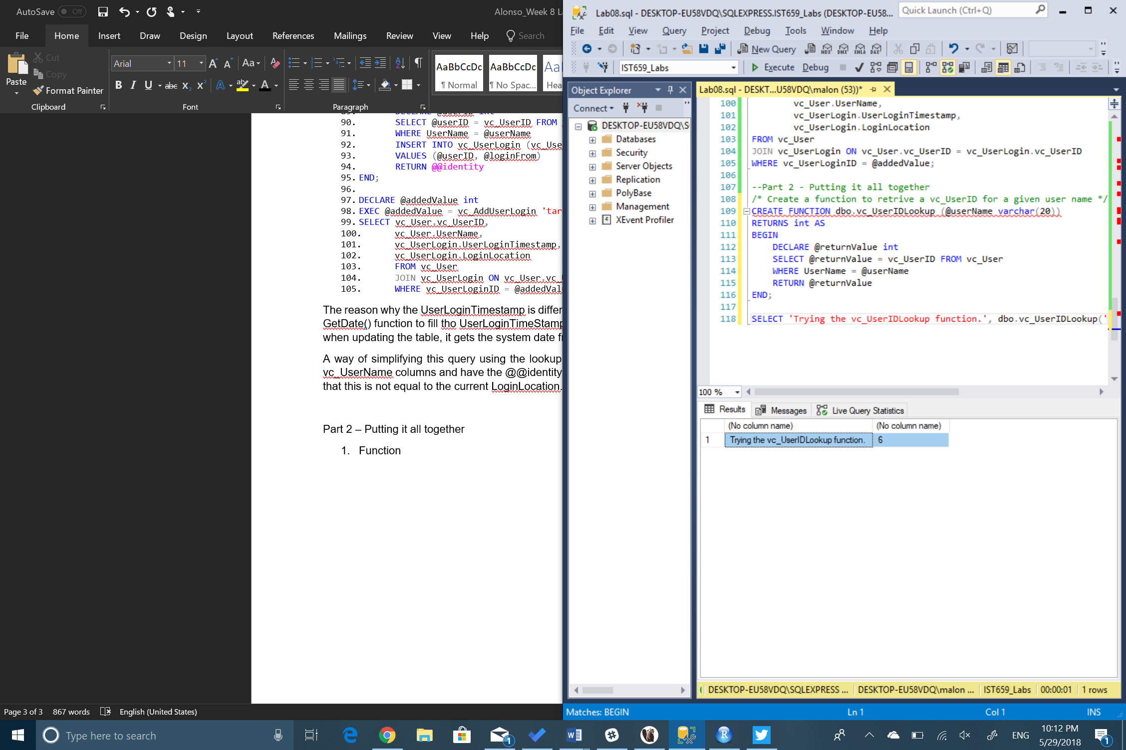

1. CountID Function

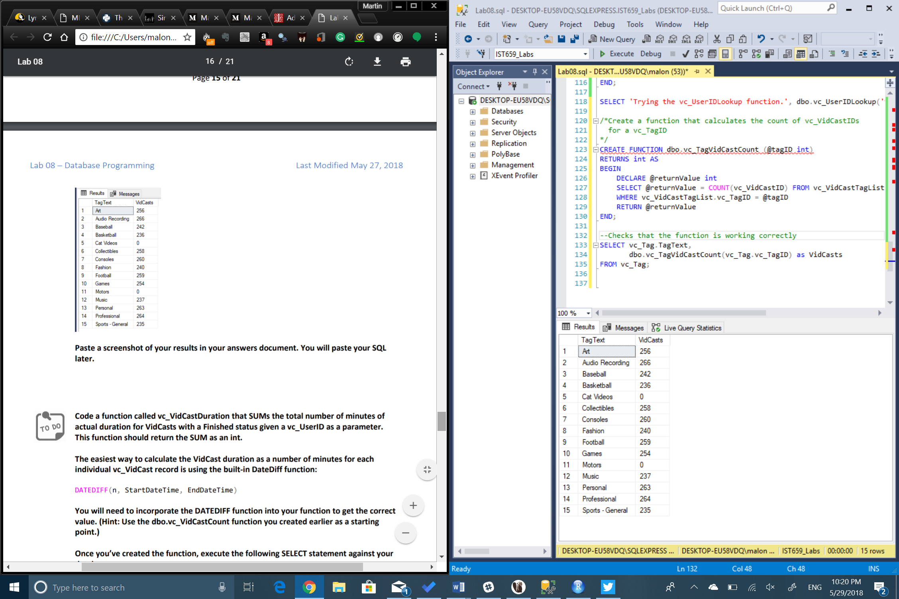

1. SUM DateDiff Function

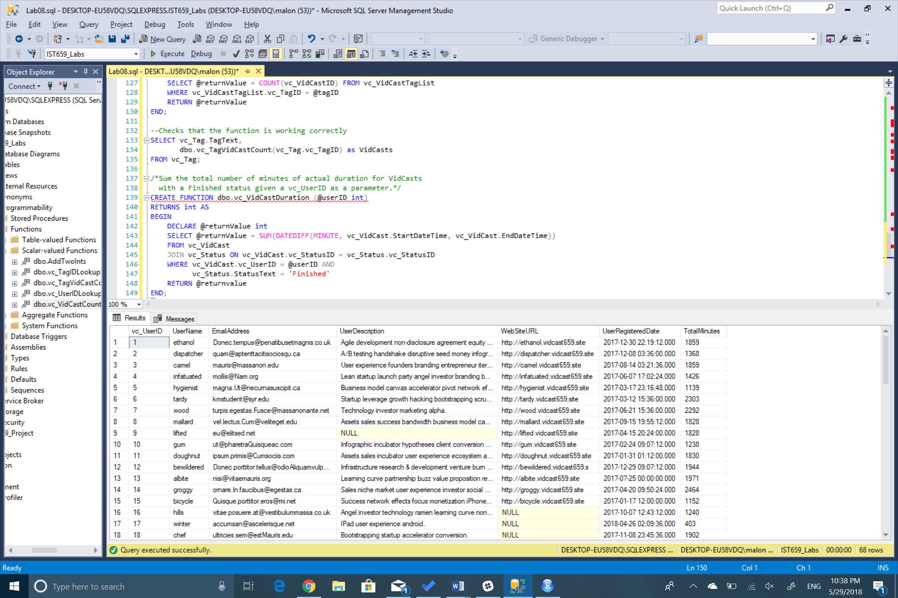

1. TagReport View

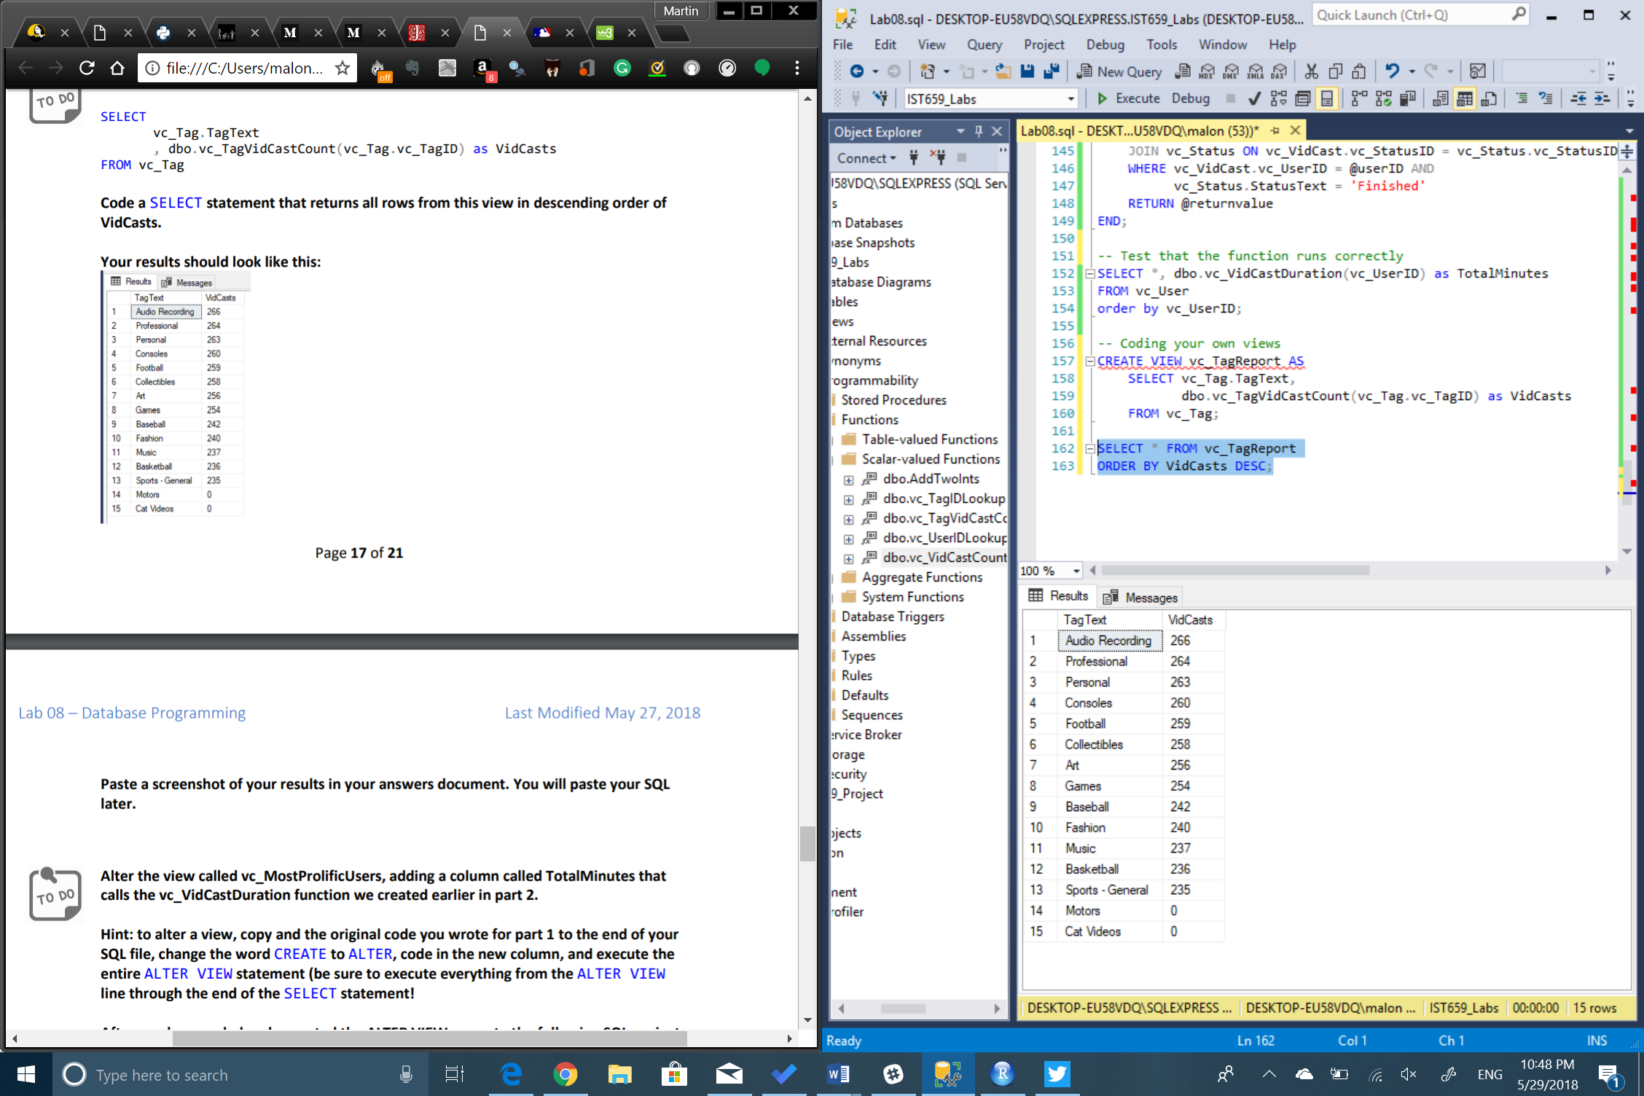

1. Altering the vc_MostProlificUsers view

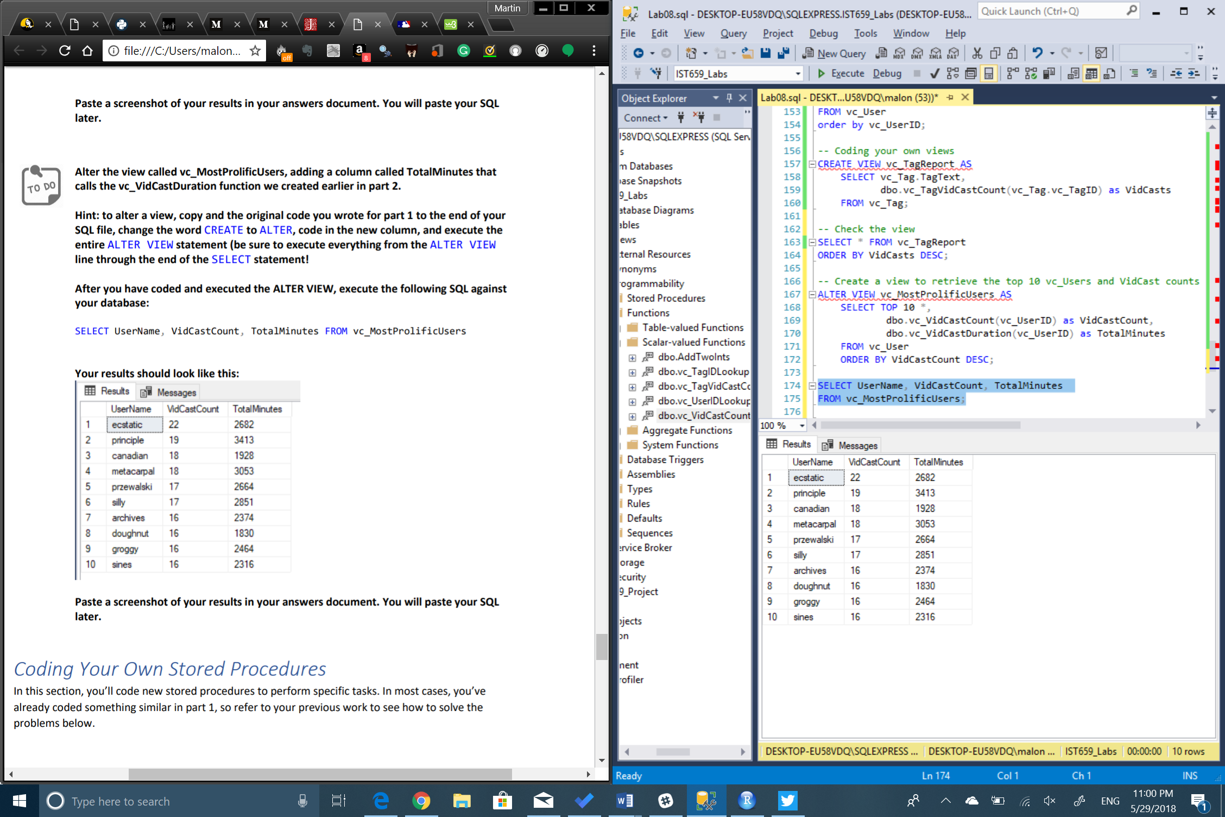

1. Create a new procedure

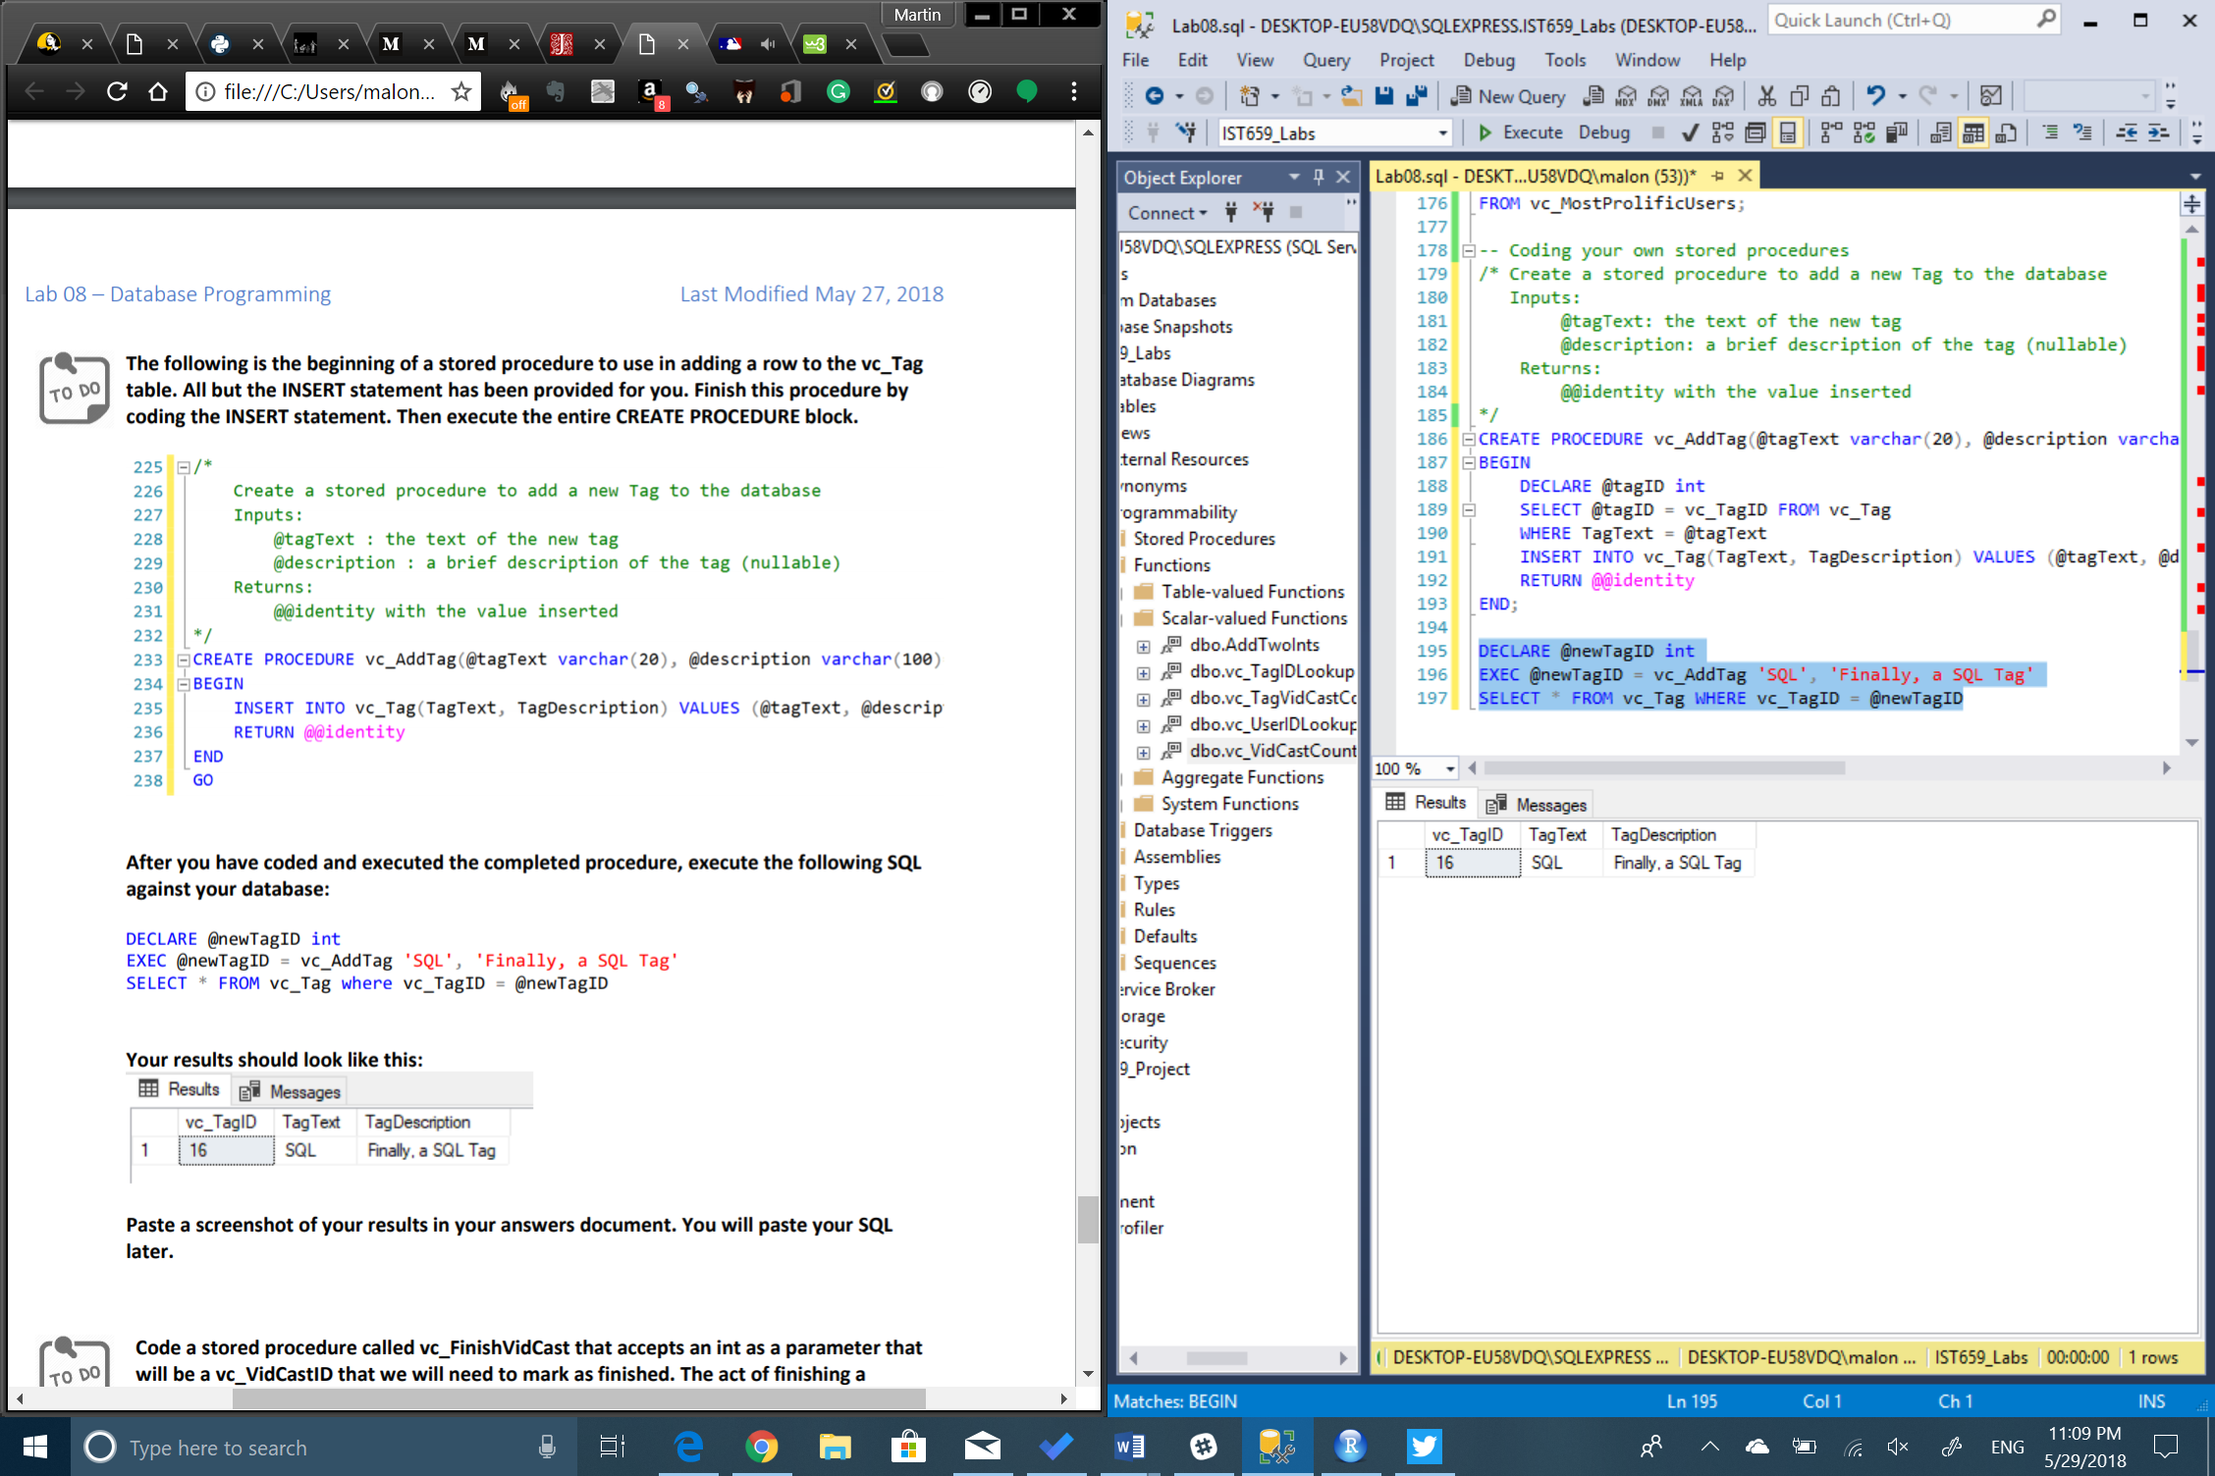

1. vc_FinishVidCast

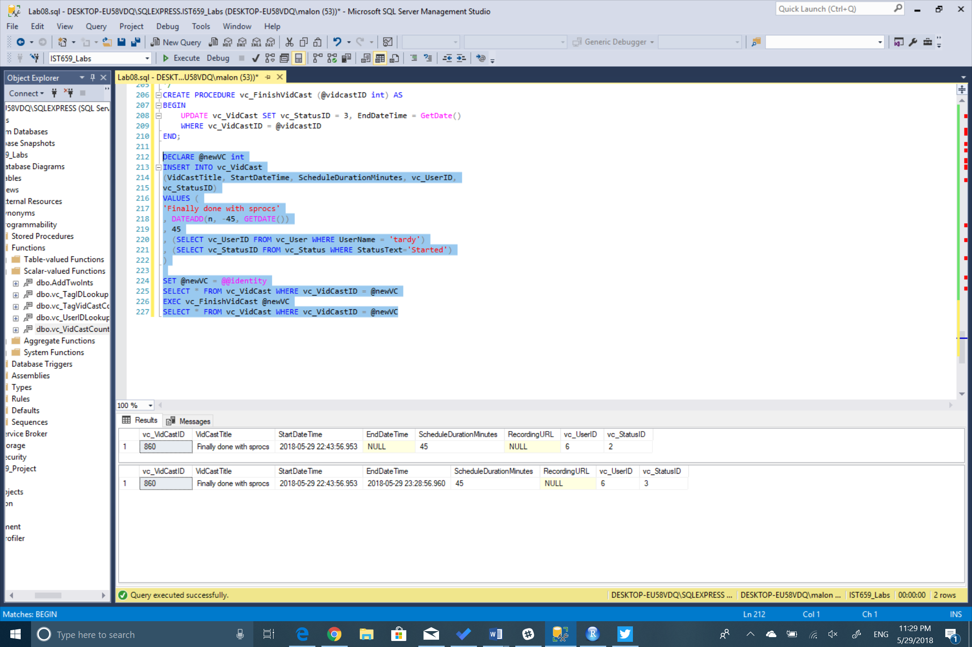

SQL Code

--Part 2 - Putting it all together

/* Create a function to retrive a vc_UserID for a given user name */

CREATE FUNCTION dbo.vc_UserIDLookup (@userName varchar(20))

RETURNS int AS

BEGIN

DECLARE @returnValue int

SELECT @returnValue = vc_UserID FROM vc_User

WHERE UserName = @userName

RETURN @returnValue

END;

SELECT 'Trying the vc_UserIDLookup function.', dbo.vc_UserIDLookup('tardy');

/*Create a function that calculates the count of vc_VidCastIDs

for a vc_TagID

*/

CREATE FUNCTION dbo.vc_TagVidCastCount (@tagID int)

RETURNS int AS

BEGIN

DECLARE @returnValue int

SELECT @returnValue = COUNT(vc_VidCastID) FROM vc_VidCastTagList

WHERE vc_VidCastTagList.vc_TagID = @tagID

RETURN @returnValue

END;

--Checks that the function is working correctly

SELECT vc_Tag.TagText,

dbo.vc_TagVidCastCount(vc_Tag.vc_TagID) as VidCasts

FROM vc_Tag;

/*Sum the total number of minutes of actual duration for VidCasts

with a Finished status given a vc_UserID as a parameter.*/

CREATE FUNCTION dbo.vc_VidCastDuration (@userID int)

RETURNS int AS

BEGIN

DECLARE @returnValue int

SELECT @returnValue = SUM(DATEDIFF(MINUTE, vc_VidCast.StartDateTime, vc_VidCast.EndDateTime))

FROM vc_VidCast

JOIN vc_Status ON vc_VidCast.vc_StatusID = vc_Status.vc_StatusID

WHERE vc_VidCast.vc_UserID = @userID AND

vc_Status.StatusText = 'Finished'

RETURN @returnvalue

END;

-- Test that the function runs correctly

SELECT *, dbo.vc_VidCastDuration(vc_UserID) as TotalMinutes

FROM vc_User

order by vc_UserID;

-- Coding your own views

CREATE VIEW vc_TagReport AS

SELECT vc_Tag.TagText,

dbo.vc_TagVidCastCount(vc_Tag.vc_TagID) as VidCasts

FROM vc_Tag;

-- Check the view

SELECT * FROM vc_TagReport

ORDER BY VidCasts DESC;

-- Create a view to retrieve the top 10 vc_Users and VidCast counts

ALTER VIEW vc_MostProlificUsers AS

SELECT TOP 10 *,

dbo.vc_VidCastCount(vc_UserID) as VidCastCount,

dbo.vc_VidCastDuration(vc_UserID) as TotalMinutes

FROM vc_User

ORDER BY VidCastCount DESC;

-- Checking that everything worked fine

SELECT UserName, VidCastCount, TotalMinutes

FROM vc_MostProlificUsers;

-- Coding your own stored procedures

/* Create a stored procedure to add a new Tag to the database

Inputs:

@tagText: the text of the new tag

@description: a brief description of the tag (nullable)

Returns:

@@identity with the value inserted

*/

CREATE PROCEDURE vc_AddTag(@tagText varchar(20), @description varchar(100)) AS

BEGIN

DECLARE @tagID int

SELECT @tagID = vc_TagID FROM vc_Tag

WHERE TagText = @tagText

INSERT INTO vc_Tag(TagText, TagDescription) VALUES (@tagText, @description)

RETURN @@identity

END;

DECLARE @newTagID int

EXEC @newTagID = vc_AddTag 'SQL', 'Finally, a SQL Tag'

SELECT * FROM vc_Tag WHERE vc_TagID = @newTagID

/* Create a stored procedure that marks a VidCast as Finished

Inputs:

@vidcastID: the int of the vc_VidCastID

@statusID: the new status

Returns:

@@identity with the value inserted

*/

CREATE PROCEDURE vc_FinishVidCast (@vidcastID int) AS

BEGIN

UPDATE vc_VidCast SET vc_StatusID = 3, EndDateTime = GetDate()

WHERE vc_VidCastID = @vidcastID

END;

DECLARE @newVC int

INSERT INTO vc_VidCast

(VidCastTitle, StartDateTime, ScheduleDurationMinutes, vc_UserID,

vc_StatusID)

VALUES (

'Finally done with sprocs'

, DATEADD(n, -45, GETDATE())

, 45

, (SELECT vc_UserID FROM vc_User WHERE UserName = 'tardy')

, (SELECT vc_StatusID FROM vc_Status WHERE StatusText='Started')

)

SET @newVC = @@identity

SELECT * FROM vc_VidCast WHERE vc_VidCastID = @newVC

EXEC vc_FinishVidCast @newVC

SELECT * FROM vc_VidCast WHERE vc_VidCastID = @newVC